Cultural-based Learning Objects: A Proposal for the Greek Diaspora
Niki Lambropoulos
Greek Education Office in London
Greek Ministry of Education and Religious Affairs
nikilambropoulos.org
Martha Christopoulou
Greek Education Office
in London
Greek Ministry of Education
and Religious Affairs
marcri13@hotmail.com

Abstract

This paper presents a theoretical framework of the implications of cultural- based learning objects in the Greek/Cypriot Diaspora. The proposed framework and the theories of cultural-based learning and blended learning (on and off line) will be described in accordance to the present environment.

Keywords: Greek/Cypriot Diaspora, cultural-based learning, blended learning

1. Introduction

There is a continuing effort to maintain and support the Greek language and culture from the Greek and Cypriot Ministries of Education in the Diaspora the last 150 years (St Sofia Church Archive). Despite the fact that many attempts were made to support these efforts, the continuing and radical changes in the educational environment especially in the recent years leave these efforts inactive. In the turn of the new millennium, the problems seem to remain the same: the way schools operate, the practical problems, such as the infrastructure and the lack of proper educational materials, the teaching methods, and teachers’ training and professional status as well as the absence of a coherent educational policy.

Introducing changes in the way schools operate and develop the infrastructure seems to be unfeasible under the specific circumstances. As such, we propose a theoretical framework that takes into account the real conditions of the educational environment and introduces a cultural-based approach aided by the new technologies.

2. ASPECTS OF TEACHING GREEK LANGUAGE IN DIASPORA
The following presentation is mainly referred to Greek–Cypriot pupils who live in the UK, since they represent the majority, and to a lesser extent to those of Greek origin who come from Greece. So, in this paper we will mainly deal with the former group whilst references to the latter will be appearing. By doing this we do not aim to use the terms interchangeably nor their needs and problems as identical. The main reasons for adopting such an approach are informed by the fact that pupils from both groups study in the same schools. Thus, any attempt to distinguish them needs to be justified on evidence based on a systematic research that is not thus far available.

2. GREEK LANGUAGE: SECOND OR FOREIGN?
One of the main characteristics of minority language such as the language of immigrants, is that it lacks of an immediate space of use (Damanakis, 1998). As regards to the language of the Greek/Cypriot pupils it has been observed that they tend to use the Cypriot dialect within their families or within the community. However, from the time pupils enter schooling they are introduced systematically to the language of the dominant group, which is the English language. Moreover, the language that they are supposed to learn, in case they want to sustain their home-land language, is the standard Greek which varies from the Cypriot dialect in pronunciation and use of different words for the same meaning. Thus, a ‘linguistic triad’ (Karyolemou, 1997) is created which enables the students ‘to make up a network of linguistic possibilities on which they can draw, theoretically at least, at any moment’. Different degrees of language acquisition and use are evident according to different generations. So, the language that the first generation Greek-Cypriots mostly use is the Cypriot dialect with some words borrowed from the English language. The mixed form and the lexical borrowings is common practice in every generation, known as Greeknghlish (ibid., 1997).

The second generation students, who were born in the UK, are more capable users of the English language and to a lesser extend of the Cypriot dialect because they rely on the English language for their every day communication as it is a language of higher status than the Cypriot one (or the standard Greek that they usually learn in extra-curriculum classes). Moreover, English is the language in which they have to compete with their fellow students in order to succeed in their school exams and to acquire an upward social mobility.

The preference in the use of the English language is clearly manifested in the third and fourth generation Cypriot students. Even in cases when they use the Cypriot dialect, the interference of the English language is obvious at all linguistic levels, in oral and written speech. Dominance of the English language over the Cypriot dialect has a direct impact on the acquisition and understanding of the standard Greek language. Furthermore, it creates practical difficulties to the students and often distances them from learning it.

It is therefore obvious that bilingualism (Greek, Greek/Cypriot and English) is not an unchangeable situation, because acquisition or loss of a language is depended on the social environment that pupils live in and learn. It is a fact that maintenance of the Greek language is depended on the relationship between English and Greek languages and on pupils’ life-chances that are measured in accordance to the standards that have been set up by the environment where they live in.

The question that comes in one’s mind is whether Modern Greek language can be considered as a second or a foreign one. According to Fengyan (2002), and Sifakis et al (2003), second language learning refers to a non-native language learnt and used within target language environment where the native speakers abound. Foreign language learning is a non- native language learnt and used with reference to a speech community outside (Fengyan, 2002; Sifakis et al 2003). In particular, although Greek and Greek- Cypriot pupils might have heard some Greek words from their childhood, or they, in a better case, use some of them in their speech, Greek language learning is definitely not a second language learning because a) it refers to a community, the Greek and Greek-Cypriot one, outside the dominant English one and b) the majority of pupils do not really speak the Greek language in their community.

From all the above, we could consider the case of learning Greek language in the UK by Greek and Greek-Cypriot pupils rather as learning of foreign language than as a learning of second one.

2.3 PROBLEMS IN TEACHING GREEK LANGUAGE
2.3.1 TEACHING AND LEARNING ENVIRONMENT
In the previous section we described some of the intricacies apparent in the learning process of the Greek language as a result of the cultural and linguistic setting they act.

In addition to what has been argued regarding to the precedence of the English language use, there are some more impediments in teaching and learning the Greek language that emanate from the specific educational context. These impediments refer to: (i) the operation of Greek Language Classes; (ii) teachers’ training and professional status; and (iii) educational policy.

Firstly, there are two main types of educational provision for these students. In the first category we find the four schools (one nursery, one primary, one secondary and one high school) that resemble in terms of curriculum, ethos, management and practices the schools of Greece. This does not come as a surprise since the Greek Ministry of National Education and Religious Affairs (MNERA) subsidies these schools and is accredited with their staffing, provision of textbooks, policy framework etc.

The second category of school provision for Greek language learning in the UK, is the Greek Language Classes (GLC). These classes operate on Saturday mornings or afternoons and during the evenings in the weekdays, in average 4-6 hours per week. Pupils attend these classes after they have attended their English school. As a result, they are often too tired to participate in the GLC, which affects their performance.

In addition, there are other, practical problems regarding the operation of the GLC. The fact these classes operate in rented English schools or in buildings owned by Greek churches, results in lacking of appropriate equipment such as projectors, computers etc, which mainstream schools would are usually provided with. Furthermore, educational materials (such as textbooks and other teaching resources) are not often appropriate due to lack of references to pupils’ experiences. The particular educational materials have been produced in Greece and are the same for Greek Diaspora schools in Europe despite the differences between the countries.
Secondly, from the teachers’ perspective the problems that intervene in the educational procedure are associated with their suitability for the roles they are carrying out. Specifically, the teachers who come to the UK, have not received sufficient training regarding to the cultural and educational context they have to teach in. For example, teachers are not aware of the educational systems of the countries or health and child protection policies. Besides, there is a significant lack of skills and training of Greek language teaching as a foreign or second one. Especially the teachers coming from Greece have to deal with the additional problem of not speaking the Cypriot dialect by themselves.

Finally, the absence of a coherent educational policy as concerns the tuition of the Greek language in the UK, indicates that the educational offices and the teachers need to improvise according to the circumstances. The consequences of this particular absence were suggested to be crucial (Lambropoulos, 2003). The most important ones are related to the absence of: (i) clarified aims and objectives of teaching Greek as a second or foreign language; (ii) systematic methodology; (iii) pupils’ assessment and (iv) online learning material.

The identification of the aforementioned problems is significant in order to design a framework towards the most beneficial solutions. Cultural-based and blended learning are two new theoretical approaches in teaching Greek as second/foreign language. Cultural-based learning supports the teaching of second/foreign language as a communication tool in accordance to the particular cultural environment that the target language exists (chapter 3.3). Cultural-based learning objects’ design follows this notion. Blended learning supports the use of the Internet and keeps the same educational environment in classroom.

3. CULTURAL-BASED AND BLENDED LEARNING
3.1 NORM-BASED LEARNING VERSUS CULTURAL-BASED LEARNING
3.1.1 Norm-based learning
Modern Greek language learning in Diaspora seems to be based on a ‘norm-based’ approach. According to Sifakis et al (2003, p.63), second/foreign language learning is commonly characterized by a tendency to uphold a series of rules that map and underlie native speakers’ linguistic competence and performance against which learners’ competence and performance is measured. So, norm-based learning approach is a rigid procedure because the target language (in our case Modern Greek) is learnt through specific linguistic rules that help learners to acquire an understanding of the grammar and structure of the language (Sifakis et al, 2003).

Norm-based learning is broadly used in Greek Language Classes. Learning Modern Greek is considered a quite difficult task because Greek language, in respect to its structure, has a rich morphology, uses movable or relaxed arrangement in the structure of the sentences, and has difficult spelling. As a result, for teaching structural, grammatical, and spelling rules, norm-based learning has been regarded as the most appropriate method. This is evident in the structure and content of students’ textbooks that are currently used as well as in the orientation of the GCSE and A Level exams. However, by teaching only structural, grammatical and spelling rules what is ignored is that language is basically an instrument for communication.

As an alternative to this, a ‘cultural-based’ approach could be adopted so that pupils could be able to connect the linguistic rules with real situation use of the target language.

3.1.2 Cultural-based learning
The cultural-based approach sees language as an instrument for communication among people and at the same time it shields learners from the negative effects of norm-based approach such as boredom, disinterest, and repulsion (Sifakis et al, 2003). According to Krasner (1999), linguistic competence alone is not enough for learners of second/foreign language. Due to the fact that language reflects the cultural values of a society, language learners need to know particular patterns of speaking behaviour, such as the use of formal or informal types of answers/questions, associated with cultural behaviour that are appropriate in the community of the target language. For example, they need to be aware of the culturally appropriate ways to address people, express gratitude, make requests, and agree or disagree with someone. They also need to be aware of the differences between the language patterns that are appropriate in the different communities they belong to, i.e. the Greek, Greek/Cypriot and the English ones. In addition, they need to be aware language patterns of the English community might be perceived differently by the members of the Greek language community and vise versa. (Peterson et al, 2003).

3.2 RELATIONSHIP BETWEEN CULTURE AND LANGUAGE
Culture and language are inseparable, because culture is an integral part of language and vice versa. So, language learning and cultural learning cannot take place independent of each other (Fengyan, 2002, and Byram 1994). For Kramsch (1993) the purpose of second/foreign language learning is a way of making cultural statements as well as learning a new way of communication. Moreover, Byram (1994) states that only if the cultural context is understood can the target language be thoroughly comprehensive. On the other hand, as language embodies the values and meanings of a culture and is the most visible expression of a particular culture, it signals people’s cultural identity (Byram, 1989 and Brown, 1987). Thus, culture and language should be strongly tied in second and/or foreign language teaching curriculum and both of them could be taught in an integrated way. Learners by getting aware of the culture of the target language might familiarise themselves with the target community. This could function as a motivation for learning the target language. Thus, learning about the target culture could work as a central mediator in the prediction of language achievement (Gardner et al, 1993).

3.3 INCORPORATING CULTURE INTO SECOND AND FOREIGN LANGUAGE
LEARNING
According to Hammerly (1982), a cultural-based second/foreign language learning can cover three areas by giving: a) information about native speakers’ society; history and geography of their country so that learners get an understanding of the world view that native speakers have of themselves and their own country (information culture); b) information about attitudes, values, etc., so that pupils can acquire particular patterns of speaking behaviour associated with culturally behaviour that are appropriate in the community of the target language (behavioural culture); and c) information about artistic and literary accomplishments so that pupils can acquire a completed view of the target language (achievement culture).

However, when teaching second/foreign language two things need to be taken into account: a) the topic areas to be included in the curriculum, and b) the learners’ and/or the native speakers’ perspective. According to Fengyan (2002) both perspectives are important for the decision making. Learners’ perspective can provide learners’ better understanding and acquisition of the language according to the purposes for which they decided to learn the target language i.e. travel abroad, communication with relatives/friends, academic development. Native speakers’ perspective can provide basic criteria for narrowing down specific aspects of the target culture that could be included to the curriculum by taking into account how native speakers’ perceive a certain place, i.e. Parthenon, or a historical event, i.e. Cyprus independence 1/10/1960.

A cultural-based learning founded equally on pupils’ and native speakers’ perspectives can include teaching aspects about places, individual persons’ way of life, history, institutions, art, music, literature (Sterm, 1993). Connecting aspects of culture to the target language learning means that teachers should introduce specific objects, traditions or notions of the culture and language of study. Students should be given background information so they can on one hand incorporate the new information into their world-view, and on the other hand work as anthropologists by exploring and understanding the target language and culture in relation to the language they use in their everyday life (Peterson et al, 2003).

Cultural activities and objectives carefully organized and incorporated into lesson plans can enrich the teaching content (Peterson et al, 2003). Teaching the target language by using authentic materials and resources from the native community might help students to engage their language studies with authentic cultural as well as linguistic experiences. As resources could be used artefacts, films, museums, photographs, and literature. These resources could be used in a blended learning environment.

4. Blended Learning

Blended learning design extends the GLC standard learning, by incorporating synchronous and asynchronous learning methods (Lambropoulos, 2003):

- In synchronous learning teachers and students have in common the element of time. Synchronous learning refers to a learning in which both students and teachers have simultaneous interactions either by being in the same classroom or by using the same online interface (e.g. Netmeeting, chat etc) when they communicate over the Internet.
- Asynchronous learning (Berge & Collins, 1993; Steiner, 1996) is a learning exchange between the learners and the teacher or between learners themselves, which takes place independently of time and space. It refers to open and distance learning (ODL) when both students and teachers do not have an indirect interaction with each other by using communicative tools such as emails, bulletin boards, online learning materials, etc.
There are a number of reasons for using blended learning for second language teaching because it:
- accommodates various learning styles
- supports learning through the use of more than one senses (multi-sensory delivery)
- strengthens all components of the educational process
- encourages learners’ involvement in the learning process through self-expression
- improves students’ critical thinking
- develops co-operative learning communication skills via interaction
- facilitates social self-organised learning online (see chapter 3.4.1)
- increases students’ and teachers’ motivation

The next chapter gives an example of using cultural-based learning objects (CLOs) regarding to their construction, indexation, packaging and delivery.

4.1 LEARNING OBJECTS (LOs)
LOs Construction: ‘Learning Objects’ (LOs), (Boyle, 2003), are reusable components in knowledge databases that provide flexibility in virtual learning environments for reusability, generativity, adaptability and scalability. The Sharable Content Object Reference Model (SCORM) (2000) suggests a standard definition of LO: it is modelled as the smallest stand-alone and meaningful component of a course that is interoperable, modular, and discoverable. The LO suggested principles are:
- cohesion: each unit should explain one thing and only one thing (Sommerville, 2000). This is precisely the difference between a LO and the exercises that can be found in the students’ textbooks used in Greek Language Classes;
- minimised de-coupling: each unit should have minimal bindings to other units. The content of one LO should not be used by another LO; in addition, it should use elements that exist in a different LO in order to create necessary dependencies for indexation, based on the grammatical or structural phenomenon that is taught; and
- motivation and interdisciplinarity: LOs should provide rich and effective learning experiences. The cohesive, decoupled and pedagogically rich LOs could offer the challenge for cross-curriculum activities (repurposability).

Designing and constructing LO units based on cultural resources, could give the opportunity to teachers and students to create a wide network of reusable material able to be adjusted to the Diasporic learners’ needs. The suggestion that Modern Greek language is quite different than the English one (see 3.1.1 and 3.1.3) results in the appearance of common mistakes that can be found in all levels of grades, for example in the use of the tenses and cases.

Teachers can easily design LOs units if they, by using Intelligent Dynamic Enquiry (IDE) methodology (Lambropoulos, 2004), investigate and identify the common mistakes their students make. IDE’s bottom up strategy is needed for three reasons: (i) to identify the common mistakes; (ii) to suggest ways of helping the students to understand and correct their mistakes; and (iii) to construct LOs basic indexation.

The three levels of designing and constructing LOs are based on the theories of distributed constructionism and non-formal learning (Resnick, 1996; Bjørnåvold, 2000; Lambropoulos, 2004). The levels are the following: (i) students and teachers’ online discussion about LOs’ design and construction can identify the structure of important units; (ii) the online environment gives the opportunity to teachers’ community to share and re-use the findings of the previous discussion/investigation; and (iii) teachers can co-operate and collaborate with the LOs’ production.

LOs Indexation: Indexation is one of the most difficult parts when deciding the designing and construction of LOs as well as the identification of growth points for self-evaluation. The suggested sequence of indexation in this paper is based on the grammar and structure of Modern Greek language, and it should make LOs searchable in a horizontal and vertical arrangement. As such, the sequence is the following: Learning Objects, Learning Clusters, Learning Sets, Learning Units.

LOs are the one-goal directed learning activities e.g. feminine, plural, nominative case. Learning Clusters (LCs) define a specific knowledge sub-domain e.g. cases in nouns. Learning Sets (LSs) refer to the domain e.g. the feminine nouns. Learning Units (LUs) describe the overall domain e.g. the nouns.

This particular indexation is the one that will be used for LOs’ packaging. We suggest the packaging that the European Knowledge Pool organisation ARIADNE has created.

LOs Packaging: LOs packaging is the final and equal important step of the procedure described above because users can find the LOs that are interested in by using keywords. Educational learning objects metadata approaches (EMD or LOM) can provide the best up-to-date wrappers. LOM generation can be achieved by using MetaData software tools based on the international standardisation initiatives as IEEE LTSC (http://ltsc.ieee.org), IMS (http://ww.imsproject.org), ARIADNE (http://www.ariadne-eu.org) and CEN/ISSS (http://www.cenorm.be/isss/Workshop/lt).

For our example, we used ARIADNE’s editor. Silo has most of the standards suggested by the LO international community (http://rubens.cs.kuleuven.ac.be:8989/silo/). ARIADNE’s supports both downloadable material that can be integrated in a co-operative organisation system and web-services. The latter build on top of SOAP (Simple Object Access Protocol), so all communication happen in XML. After issuing a query, XML description that fulfil the query can be downloaded for XML binding. ARIADNE supports the creation of new metadata files, allows modification of existing LOM in terms of data, is valid in terms of data values (Sampson et. al, 2002). Additionally, ARIADNE provides a European Knowledge Pool of LOs facilitating interaction and LOs exchange between ten countries in both English and regional languages.

LOs Delivery: LOs delivery can happen in two ways: by using multimedia (video, audio, text, graphics) re-usable LOs from:
- the internet, preferably integrated in learning management systems. The latter could support blended learning requirements such as flexibility of time and place, coping with increased number of student, supporting communities of practice, sharing and re-using different kinds of educational material and collaborative work.
- CD-ROMs. Support and further development can be achieved by online collaboration in communities of practice. The re-usable LOs in online and offline networks can be connected and distributed following their indexation as a user can send one LO to other users as well as to a central LOs repository i.e. ARIADNE, where the LO will be stored and rearranged according to its indexation in the European Knowledge Pool.

For online delivery integrated in learning management systems, Zaphiris et al (2003) presented two crucial impediments regarding to online Greek language learning: (i) problems with the use of Greek fonts and (ii) lack of technical support. Online interactions in learning communities increase the feeling of co-presence with other Greek origin students and help them to identify themselves in the Greek community.

4.2 Cultural-based learning objects (CLOs)

Cultural-based learning objects (CLOs) are suggested to follow LOs indexation as described in chapter 4.1. Regarding to the previous theories of cultural-based and blended learning, the designing of LOs can be enriched by information about the target culture. Grammatical and structural phenomena can be presented by using artefacts, music, films, and everything that refers to the way that people of the target language live their lives. For example, students can be presented with and be given background information about art objects (jewelry, crafts, embroideries, paintings, etc.) in a particular cultural context. As a next step teacher can ask students to find information about the art object/objects in question (Peterson, 2003). It is students’ responsibility now to conduct a research by using the clues were given and submit their understanding in the online discussion group relevant to the specific CLO. The findings of their research can be presented in the class for example in the form of a written summary and identified CLOs, and/or by making an oral presentation in the classroom about the cultural relevance of the art object/objects. According to Peterson (2003), these activities can serve for expanding the discussion about larger cultural, historical, and linguistic factors that tie with the art object /objects.

5. Example of CLOs

We present an example of a CLO that refers to the agreement between adjectives and nouns in the neutral, first case singular and is titled ‘The garland for the 1st of May’ (Μαγιάτικο Στεφάνι). The suggested level is for year four in GLC. This could be used in a learning management system, e.g. Claroline as adjusted for the Greek university network (GUNET, htpp://eclass.gunet.gr). In Figure 1 the interface provides the options of Agenda, Links, Documents, Video, Students' Exercises, Announcements, Users, Forums, Exercises, Groups, Online Chat, and the Description of the Course.
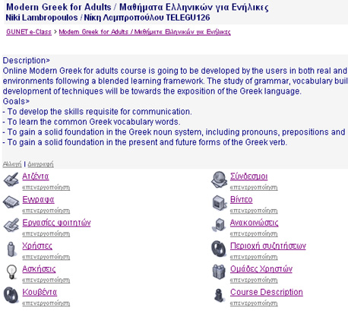

Figure 1. The Interface

The Learning Subject is the Greek Grammar. The Learning Unit refers to the ‘adjectives’. The Learning Set is about the agreement between nouns and adjectives. According to Tsolakis (2000:144), adjectives agree with nouns in gender, singular or plural and case. The Learning Cluster refers to the agreement between neutral nouns and adjectives. The Learning Object is about the agreement between the neutral nouns and adjectives in the nominative singular case.

The LO will be tight with a particular tradition, which is common in Greece and Cyprus. Greek people celebrate spring’s coming by making garlands from flowers on the 1st of May and they hang at the front doors of the their homes. The purpose of doing this is to derive energy from the nature.

The students will be shown a painting by Apostolos Geralis (1886-1983) and be engaged in activities that will introduce them to traditions for the 1st of May and the grammatical phenomenon examined. Since we are working in a blended learning environment, the students will be called to make a garland in their classrooms and search on the internet for relevant information. Moreover, they can be asked to find the significance of making garlands in other, past or present, cultures. The findings of the research can be presented either on the internet or in the classroom.

The CLO constitutes by definition of the grammatical phenomenon and includes a small text for the tradition in the Greek language, the painting, one example (underlined in the text) as well as two exercises for assessment.

The text:

Το Μαγιάτικο στεφάνι το φτιάχνουν οι νοικοκυρές την παραμονή της Πρωτομαγιάς. Πριν τη δύση του ήλιου το κρεμούν πάνω από την εξώπορτα. Με αυτόν τον τρόπο καλωσορίζουν την άνοιξη.
Την επόμενη μέρα, όλοι μαζί με τις οικογένειές τους πηγαίνουν στις εξοχές για να γιορτάσουν την Πρωτομαγιά.

Greek housewives make in the evening of 1st of May eve a garland from flowers. They hang them on their front doors. In this way they welcome spring.
The next day everybody along with his/her family goes to the country to celebrate the 1st of May.
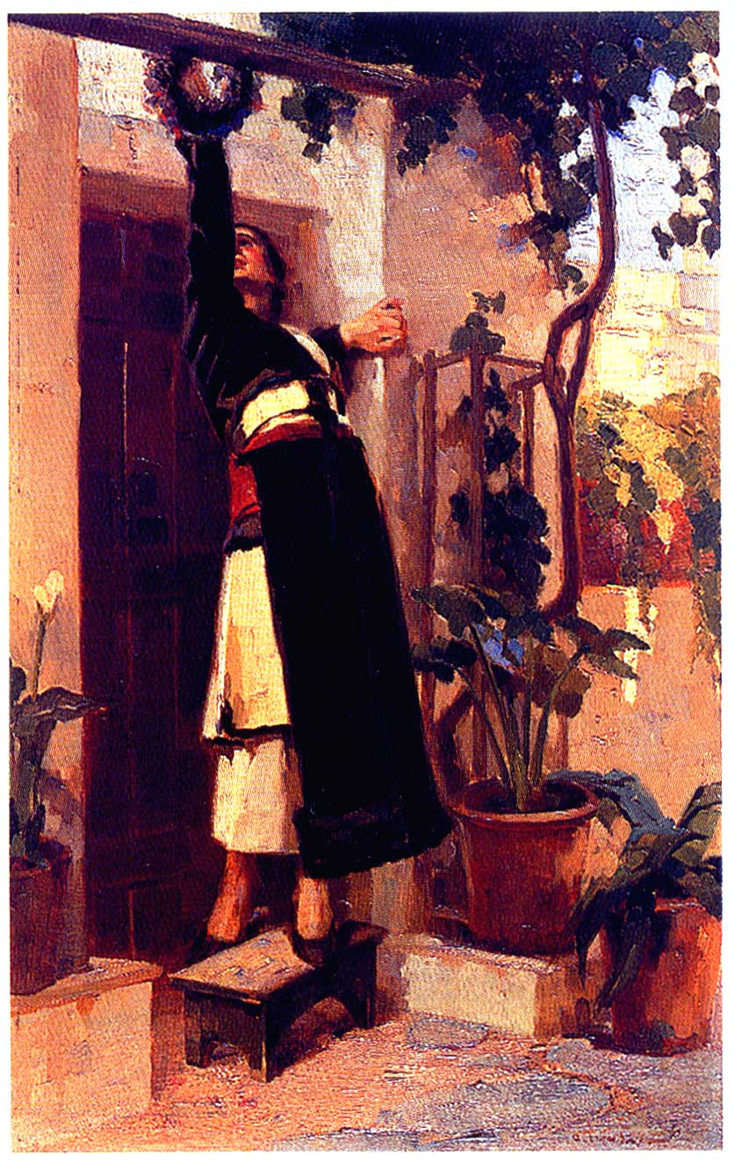

Άσκηση 1. Βάζω τις καταλήξεις στα παρακάτω:
Το μαγιάτικο στεφάνι
Το πράσιν… πάρκο
Το άσπρ… περιστέρ…

Άσκηση 2. Βάζω τις καταλήξεις στα παρακάτω:
Το λουλούδιν…. στεφάν…. που βάζουμε στην πόρτα του σπιτιού μας την Πρωτομαγιά καλωσορίζει την άνοιξη. Το κίτριν… λουλούδ… του Μάη, λέγεται μαγιολούλουδο στολίζει τα περισσότερα στεφάνια.

Figure 2. The garland of May. Apostolos Geralis (1886-1983).

Θέμα για συζήτηση: Εσείς πώς γιορτάζετε την Πρωτομαγιά στον τόπο που μένετε;
(Link for Discussion Forum on cultural or/and grammatical phenomena).

In figure 3 students and teachers’ discussion about the learning object will be part of both areas of the nouns or the adjectives.

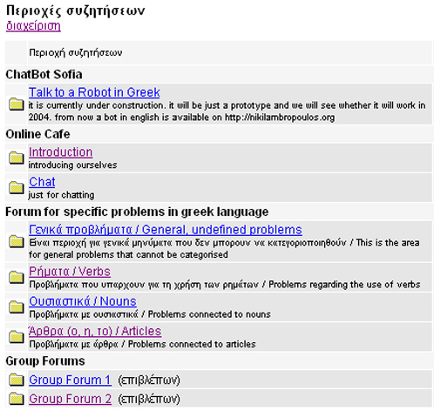

Figure 3. Discussion Forums

In figure 3 the discussion forums are generated according to grammatical and structural phenomena.
5.1 Technical Issues on building multimedia CLOs

All mediums can be used to create LOs and specifically CLOs as soon as it is one-goal-directed activity in relation to specific grammatical and structural rules. LOs should be arranged in a pre-defined indexation and metadata should be attached, based on the previous indexation. We prefer XML programming language for the metadata because of its future use in application and intelligence systems. The contemporary editors we mentioned in the previous chapter are able to attach XML metadata in any kind of a file e.g. ppt, doc, jpg, gif, html, avi, wav, simulation etc.

Building interesting CLOs is of a great issue. Instead of having to deal with one parameter as with all LOs produced up to now, we are dealing with two, the cultural and the grammatical and structural phenomena. As such, the use of interacting properties with text, image and sound might be a better solution. As such, a multimedia CLO, technically speaking, needs an html environment to be integrated. The properties that we have to consider are the language (use more than one languages) and the design i.e. the size, the navigation bar, the spaces for the information and the amount of information used, the maximum amount of CLOs in a learning cluster, the colours and the interactive elements. As such we suggest: (i) the size should be the maximum of 720X420 pixels for all monitors; (ii) the navigation bar might be better to appear at the bottom in order not to let the mouse cross over the CLO; (iii) information should be located either at the bottom or/and on the right panel as well as the buttons for the interactivity. Information is limited in our opinion should be as limited as possible because of the technical restrictions. The develop is the one who decides in each case what kind of information is required; (iv) the maximum amount of CLOs in a learning object and cluster is suggested to be eight for both; (v) the colours are not supposed to distract or to interfere with the CLOs but to create a pleasant environment; (vi) interactive elements is better to provide the learner with immediate feedback as well as with explanation and instructions; (vii) a button for more information on the web regarding the cultural phenomenon; (viii) a button for the discussion forum regarding the grammatical phenomenon; (ix) a dictionary and (x) a close window button.

CLO DESIGN:
An example for designing a multimedia CLO is here made by Macromedia FlashMX:

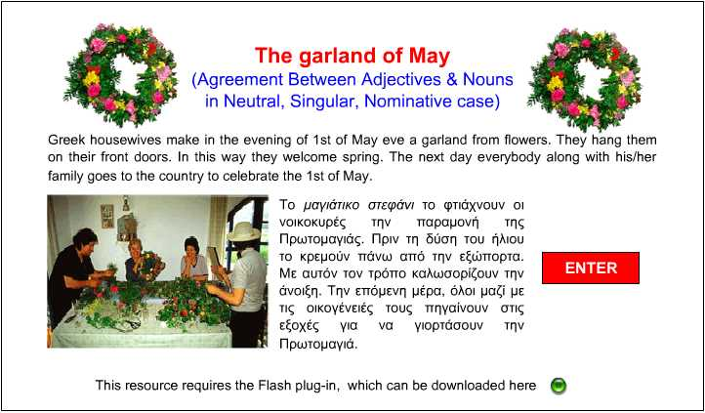
Figure 4. Introductory page from the Cultural-based Learning Object.
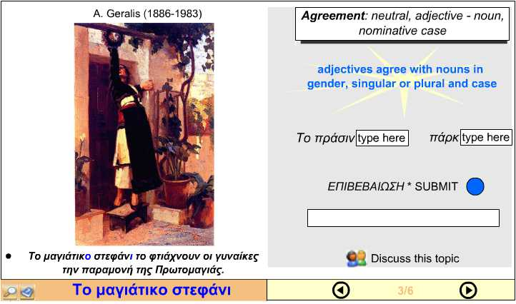
Figure 5. Page 3 from the Cultural-based Learning Object

ARIADNE METADATA:
The National Greek School Network was not part of ARIADNE at the time we were writing the paper. As such, the metadata for the document (SWF file) are inserted in English language. An example for creating XML metadata using ARIADNE for a multimedia CLO is here:

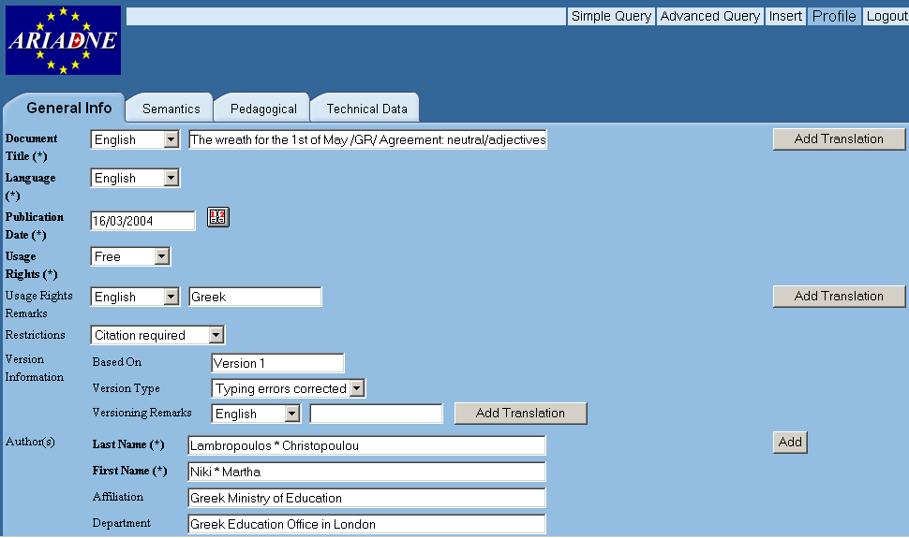
Figure 6. Inserting metadata in ARIADNE

After uploading the file, there are options that are important to be filled: general information of the file, Semantics, Pedagogical and technical data. ARIADNE application makes the file searchable using vertical and horizontal search.
Teachers are able to create CLOs on their own, since almost all create educational material for their own purposes. The instructions for design do not affect the quality of any learning object; for instance an A4 paper does not affect the Greek literature as such. The conception behind our approach is the insertion of XML metadata in the files the teachers build anyway, following the principles of LOs and create a valuable network for blended learning.

4. Conclusions

The initial idea for this particular proposal was that there should be a better way for teaching and learning Greek language in GLCs than the traditional one described in chapter 3.1.1. Moreover, since the learning environment in GLCs is difficult to change at the near future, and the problems that teachers’ and students’ face in teaching and learning the Greek language cannot be solved at the moment, we think that blended cultural –based learning could provide solutions for increasing interest in teaching and learning Greek language. The main aim of using cultural-based learning objects is to introduce students in the target culture, the Greek one, as well as teaching grammatical and structural phenomena of the Greek language in a way that they could enhance their interest in learning it. The suggested proposal might need further development since it is the first attempt to construct cultural learning objects for teaching Greek as second/foreign language. For the design and construction of LOs it is needed firstly an inquiry into students’ needs and common difficulties in learning the Greek language and secondly a cooperation and collaboration of researchers, teachers, linguists, curriculum developers, artists, and multimedia designers in order to produce high quality cultural-based learning objects.

Acknowledgments

We would like to thank the team of ECLASS GUNET for providing the platform in order to facilitate our activities and allowed us to work in the area of research for the Greek Diaspora; Erik Duval and Stefaan Ternier from ARIADNE for giving us access to Silo and their overall help and cooperation, Richard Hayens for his suggestions on CLO development as well as Spyros Themelis and Sophi Danis for their valuable help and support.

References

ARIADNE European Knowledge Pool and Silo. Available on the Internet http://www.ariadne-eu.org and http://rubens.cs.kuleuven.ac.be:8989/silo/ Last Access 14.03.04.
Berge, Z.L. & Collins, M.P., (2000) Perceptions of e-moderators about their roles and functions in moderating electronic mailing lists. Distance Education: An International Journal, Vol. 21, No.1, pp. 81-100.
Boyle, T., (2003), Design principles for authoring dynamic, reusable learning objects. Australian Journal of Educational Technology, Vol. 19, No.1, pp.46-58. http://www.ascilite.org.au/ajet/ajet19/boyle.html.
Brown, H.D., (1987) Principles of Language Learning and Teaching. Englewood Cliffs, NJ: Prentice-Hall.
Byram, M. (et al) 1994 Teaching-and-Learning Language-and-Culture. Bridgend:WBC Ltd.
CEDEFOP, Bjørnåvold, J. (2000). Making Learning Visible: identification, assessment and recognition of non-formal learning in Europe. Luxemburg.
CEN/ISSS, European Committee for Standardisation. Available at http://www.cenorm.be/isss/Workshop/lt Last access 14.03.04.
Geralis, A. (1886-1983). The garland of the 1st of May’. Oil on hardboard, 50X31,5. The Greek Sale III (1995). Athens: CHRISTIES & Benaki Museum.
Cultural-based Learning object link. Available on the Internet, http://users.ach.sch.gr/nikilambropoulos/ODL/LO/CLO.html Last access 18.03.04.
Damanakis M., (1998) Η Εκπαίδευση Παλλινοστούντων και Αλλοδαπών Μαθητών στην Ελλάδα, Αθήνα: Gutenberg
Fengyan, Ch., (2002) Incorporating Culture into Foreign Language Teaching Programmes, www.eltexpress.com
Gardner, R. C. and MacIntyre, P. D. 1993. A Student’s Contributions to Second-language Learning. Part II: Affective variables. Language Teaching 26, 1-11.
Georgoyiannis P., (1999) Θάματα Διαπολιτισμικής Εκπαίδευσης, Αθήνα: Gutemberg.
GUNET, Greek University Network. Avalable at htpp://eclass.gunet.gr Last access 14.03.04.
Hammerly,H., (1982) Synthesis in Second Language Teaching. Blaine, Washington: Second Language Publications.
IEEE (2002). Draft Standard for Learning Object Metadata. http://ltsc.ieee.org/doc/wg12/LOM_WD6_4.pdf Last access 14.03.04.
IMS (http://ww.imsproject.org).
For our example, we used ARIADNE’s editor. Silo has most of the standards suggested by the LO international community (http://rubens.cs.kuleuven.ac.be:8989/silo/).
Kramsch, C., 1993. Context and Culture in Language Teaching. Oxford: Oxford University Press.
Krasner, I., (1999). The role of culture in language teaching. Dialog on Language Instruction, Vol.13, No.1-2, pp.79-88.
Lambropoulos, N. (2004). Intelligent Dynamic Enquiry for Innovation Technology: towards Multi-Agent Systems. In the Proceedings of the Conference Artificial Intelligence and Applications, AIA 2004 as part of the Twenty-Second IASTED International Multi-Conference on Applied Informatics. Austria: Innsbruck: 183-188.
Lambropoulos, N., (2003). ICT Projects in the Greek Diaspora: U.K. case in Proceedings, 6th International Conference for Multiculturalism. Patras, Hellas: University of Patras Press (to appear).
Peterson, E., and Coltrane, B., (2003) Culture in Second Language Teaching, EricDigest, available Jan. 2004.
Resnick, M. (1996). Distributed Constructionism. Proceedings of the International Conference on the Learning Sciences Association for the Advancement of Computing in Education. Northwestern University. Internet.
http://llk.media.mit.edu/papers/archive/Distrib-Construc.html Last access 13/2/04
Retalis, S. (2003). Evaluating the acceptability of Web-based Learning Management Systems. In the Proceedings of the 1st International Conference in ICT in Diaspora, Hellenic Education Office of the Greek Embassy & Cyprus Education Mission. London, 2003, pp. 74-79.
SCORM, “Advanced Distributed Learning Initiative. Sharable Courseware Object Reference Model” Version 1.0. January 31, 2000. Available at http://www.adlnet.org/ Last access 15.03.04.
Sifakis, N. and Sougari, A., M., (2003) Facing the Globalisation Challenge in the Realm of English Language Teaching, Language and Education, Vol. 17, No. 1.
SOAP, Simple Object Access Protocol. Available at http://www.w3.org/TR/soap/ Last access 16.03.04.
Sommerville, I., (2000). Software engineering, 6th Ed. Addison-Wesley.
St Sofia Church Archive. Hellenic Community. Available on the Internet http://hellenic-education-uk.europe.sch.gr/comm/community.htm Last access 14.03.04.
Steiner, V., (1996). What is Distance Education. Distance Education Learning Resource Network (DLRN), Vol. 1, No 1.
Sterm, H.H., (1993 2nd ed.) Issues and Options in Language Teaching. Oxford: Oxford University Press.
Tsolakis, T. (2000). Modern Greek Grammar 16th Edition. Athens: Organization for Publishing Books for the Greek Schools.
Vassiliou, S. (1902-1984). Neighbourhood. Oil on panel, 40X50,3 cm. The Greek Sale III (1995). Athens: CHRISTIES & Benaki Museum.
Zaphiris, P., Zacharia, G., and Rajasekaran, M.S., (2003) Distributed Constructionism through Participatory Design. in Ghaoudi, C. (Ed) Usability Evaluation of Online Learning Programs, Idea Group Publishing, London, UK.

http://users.ach.sch.gr/nikilambropoulos/ODL/LO/CLO.html

Νίκη Λαμπροπούλου / Niki Lambropoulos ΜΑ, PhD st
Greek Education Office in London
Teacher, ICT Project Manger
nikilambropoulos.org

Niki Lambropoulos is a PhD student in Computing, at London Metropolitan University. She works as a Greek Language teacher and ICT Project Manager for the Greek Education Office in London. Niki has an educational background towards ICT. Her interests include teaching and learning in creative environments, education for social change, the use of ICT in Diaspora, the Greek culture in the Greek Diaspora, and Multi-Agent Systems in Learning Environments.

Μάρθα Χριστοπούλου/ Martha Christopoulou
Greek Education Office in London
Teacher and Artist
marcri13@hotmail.com

Martha Christopoulou is an MA student in Art, Craft and Design Education at University of Surrey Roehampton. She works for the Greek Education Office in London as a Greek Language teacher in Greek Language Classes. Martha is also a practising artist (iconographer). Among her interests is the importance of culture and cultural heritage in human life; the ways that art reflects culture that produced it; and the ways that art combines social and personal expression.

There are many manifestations of the community in relation to the Greek Diaspora in the UK. Some of the most significant fori of this community, where the Greek language is predominantly used, are the Greek Orthodox Churches (which are estimated to be more than one hundred), the various Greek youth clubs, associations, institutions and organisations that are established for many decades now , the London Greek Radio etc.
Other commentators refer to the same phenomenon as ‘switch-coding’ (cf. Georgoyiannis, 1999).
For a broader discussion on the issues of linguistic variation and linguistic change, see Karyolemou, 1997.
Anecdotal evidence from Greek school teachers, shows that it is not rare the case where Greek/Cypriot students express their apathy to learn the Greek language since they perceive it as having no benefit in their lives. In many cases they find pointless to learn a language that will have a very limited role in their future, especially when this language happens not to be the same as the one they use at home. The ‘mismatching’ between the Cypriot dialect and the standard Greek and the comparison between the two dialects seem to be another impediment since pupils feel that they do not speak the ‘proper’ Greek and as a result they impose themselves into a self-censorship.
According to the Greek Ministry of Education, by 1996 there were 523 GLC in the UK and 5.890 students attending them (in Georgoyiannis, 1999:83-4 ).
GCSE stands for General Certificate for Secondary Education and A Levels are the entry exams for any University in the U.K.
According to Fengyan (2002) authentic materials are these that are taken from real life without being adapted such as radio/ T V programs, magazines newspapers, maps of cities, postcards, train/bus tickets, etc. These can give learners some insights about native speakers daily life.

